Nexora CRM contacts
Document 5 of the Nexora learning guides
Source snapshot 14 October 2026 at 06:41 UTC
Understand the contact list, create form, detail screen and connected person information.

Recognise the screen and its scope
Open /relationships/contacts. CRM routes use port 3017; member routes use 3018; public website routes can use 3019. Brackets name a route parameter, not text to paste into a browser. Choose a real record or site id from the application.
This guide covers Contact creation and editing; Status category owner and team; Structured names and general information; Addresses communication social links and consent; Notes tags timeline photo and connected memberships.
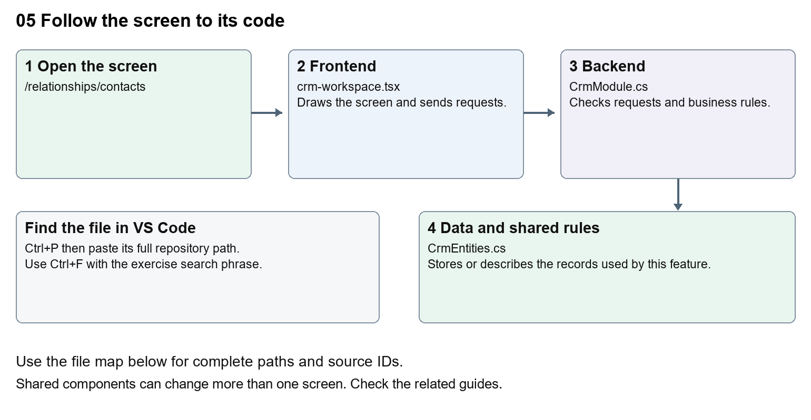
The diagram shows the file roles. The full paths below are what you paste into Ctrl+P.

Find the files in VS Code
Role | File and source ID | What it does
Screen | S0080 crm-workspace.tsx | Main UI or route for this topic
Server | S0250 CrmModule.cs | Endpoints or server rules
Data | S0255 CrmEntities.cs | Data shape or persistence structure

Screen S0080
apps/web/src/features/crm/crm-workspace.tsx
Server S0250
backend/src/Modules/Nexora.Modules.Crm/CrmModule.cs
Data S0255
backend/src/Modules/Nexora.Modules.Crm/Domain/CrmEntities.cs
The complete HTML manual opens these source IDs inside its Source library. The Word manual shows short labelled extracts so you can learn the flow before reading large files. Each individual Markdown guide includes its complete primary files after the walkthrough.

Follow the request and the records
1. The contacts route passes contact as the record kind.
2. useCrmListing requests /api/v1/crm/records with filters and paging.
3. Selecting a row loads its detail and related sections.
4. The create or edit form sends JSON with the record kind and version.
5. The CRM module validates the request and saves tenant-scoped records and activity.

Read the code with an explanation
Contacts and Accounts use the same CrmWorkspace with a different kind. Small components handle general information, communication permissions, addresses and associations. A field label is the readable text; a name or JSON key is the address of the data. Change the label without renaming the key. Version values help detect another user changing the same record.
Source reference S0080 apps/web/src/features/crm/crm-workspace.tsx
Selected opening lines with their original numbers. The complete file is in the HTML source library.
0001 "use client";
0002 import styles from "./record-detail.module.css";
0003 import listingStyles from "./record-listing.module.css";
0004 import { RecordSection } from "./record-section";
0005 import { RecordTimeline } from "./record-timeline";
0006 import { RecordDataAudit } from "./record-data-audit";

The import lines lead to shared components and helpers. Start at the exported component or route function; follow the request helper to the server rather than assuming the whole feature lives in this file.
Source reference S0250 backend/src/Modules/Nexora.Modules.Crm/CrmModule.cs
Extract from source line 47. A fragment from a long line is shown without the rest of that line.
0047 var api = endpoints.MapGroup("/api/v1/crm").WithTags("CRM").RequireAuthorization("crm.read");

On the server, look for MapGet to load records, MapPost to create or perform an action, MapPut or MapPatch to change data, and RequireAuthorization for permissions. Some shared methods register endpoints indirectly. Find SaveChangesAsync to see the database write. A request method alone does not tell you every side effect.
Source reference S0255 backend/src/Modules/Nexora.Modules.Crm/Domain/CrmEntities.cs
Selected opening lines with their original numbers. The complete file is in the HTML source library.
0001 namespace Nexora.Modules.Crm.Domain;
0003 public abstract class TenantRow
0004 {
0005 public Guid Id { get; set; } = Guid.NewGuid();
0006 public Guid TenantId { get; set; }
0007 }

Follow model fields to their request names and database mapping. An id points to a particular record. A tenant id limits the organisation. A version or concurrency stamp protects newer edits. Some model files describe contracts rather than tables; check the owning DbContext before assuming storage.

Make or trace your first change
1. Press Ctrl+P and open apps/web/src/features/crm/crm-workspace.tsx.
2. Press Ctrl+F and search for Label Name. In this snapshot it appears at line 107.
3. Change the contact label text only inside the kind-based Label. Leave name="name" intact. Open the Contact create form, confirm the new label, then undo without creating a real contact.
4. Replace only Label Name with Contact display name in that intended location. Keep quotes, tags, JSON keys and routes intact.
5. Save with Ctrl+S. Inspect Problems and the local screen. Review the diff and restore the original text when you finish practising.
Extract from source line 107. A fragment from a long line is shown without the rest of that line.
0107 <Label title={kind === "contact" ? "Label Name" : "Account Name"}><input className={input} name="name" defaultValue={row?.name} maxLength={160} required /></Label>

These exercises have not been applied to the application. Their search phrases are verified against the captured source. Line numbers can move; the phrase and file path are your main navigation aids.

Check a change and diagnose problems
Confirm the original screen still loads, the changed words appear in the intended place, and another screen using the same component still behaves correctly. If an action fails, inspect the browser Network response, the relevant helper and server validation message. Use the common error table at the beginning of the manual. Reload on a version conflict instead of removing the version check.
A syntax error after a text edit usually means a quote, brace or closing tag changed. Compare your diff with the original. An unchanged browser result can mean the wrong port, a saved published configuration overriding a default, or a running API that has not reloaded.

Understand the current limits
Contact access requires crm.read; writes and files need their own permissions. An archived record remains stored. Editing labels does not migrate data or change matching and consent rules.

Continue learning
Related guides 06 Nexora CRM accounts and associations, 07 Nexora record listings and saved views, 08 Nexora record profiles and related information, 18 Nexora imports exports and migration, 29 Nexora documents evidence and file safety.

